A. Problem Analysis
Contents
I. INTRODUCTION 1
1.1. Background and Project Summary 1
1.2. Commitment Objectives 1
II. PROBLEM AND USER ANALYSIS 1
2.1. Identifying Target Users 1
2.2. Pain Points 1
2.3. Use Scenarios 2
III. VALUE PROPOSITION AND SUCCESS METRICS (KPIs) 2
3.1. Value Proposition 2
3.2. Key Performance Indicators (KPIs) 3
IV. METHOD AND TECHNOLOGY DESIGN 3
4.1. Platform Choice 3
4.2. Technology Stack 4
4.3 System Architecture 4
V. DATA AND RESOURCES 5
5.1. Data Sources 5
5.2. Data Flow 6
VI. PROJECT ROADMAP 6
6.1. Development Approach 6
6.2. Timeline 6
PHASE I: ANALYSIS AND DESIGN (Weeks 1-2) 6
Week 1: Research & Planning 6
Week 2: UI/UX Design & Technical Setup 7
PHASE II: BACKEND DEVELOPMENT (Weeks 3-4) 8
Week 3: Database & API Foundation 8
Week 4: Advanced Features & Data Population 9
PHASE III: FRONTEND DEVELOPMENT (Weeks 5-6) 9
Week 5: Core UI Components 9
Week 6: Timeline & Detail Pages 10
PHASE IV: TESTING AND OPTIMIZATION (Weeks 7-8) 11
Week 7: Integration & Content Completion 11
Week 8: Testing & Bug Fixes 12
PHASE V: FINALIZATION AND LAUNCH (Weeks 9-10) 12
Week 9: Final Polish & Documentation 12
Week 10: Deployment & Launch 13

I. INTRODUCTION

1.1. Background and Project Summary
The overall project goal is to address the challenge of making Vietnamese history more accessible and engaging by developing an interactive web application.
Project Summary: An interactive web platform featuring a Vietnam map integrated with historical events, timelines, and educational content that makes learning Vietnamese history engaging and visually intuitive.

1.2. Commitment Objectives
- Clearly define target users and their pain points
- Define the core value proposition and success metrics
- Select appropriate technologies and design the system architecture
- Identify reliable data sources and required resources
- Establish a realistic development roadmap and task assignments

II. PROBLEM AND USER ANALYSIS

2.1. Identifying Target Users
Primary Users:
- High school and university students studying Vietnamese history
- Teachers seeking supplementary educational materials
- Vietnamese diaspora wanting to learn about their heritage
- Tourists and international learners interested in Vietnamese culture
- History enthusiasts and researchers
User Demographics:
- Age: 15-35 years old (primary), 35+ (secondary)
- Tech-savvy individuals comfortable with web applications
- Users preferring visual and interactive learning methods

2.2. Pain Points
Current Problems:
- Traditional textbook learning is passive and often boring
- Difficulty visualizing geographical context of historical events
- Information overload from scattered sources (books, social media, newspapers)
- Lack of interactive tools to explore history at one's own pace
- Hard to understand relationships between different historical events
- Limited resources that combine geography with history
- No centralized, reliable platform for Vietnamese history in an engaging format

2.3. Use Scenarios
Scenario 1 - Student Preparation: Mr. Viet has a history exam next week but hasn't paid attention in class or read his textbook. Watching YouTube videos is too time-consuming. He searches Google and finds this website. Using the interactive map, he quickly navigates through different historical periods, clicks on events relevant to his exam, and learns through engaging visual timelines and concise summaries. He passes his exam and continues using the site out of genuine interest.
Scenario 2 - Teacher Enhancement: Ms. Lan is a history teacher who wants to make her lessons more engaging. She uses the website in class, projecting the interactive map on a screen. Students explore different dynasties by clicking regions on the map, seeing how territorial boundaries changed over time. The visual approach increases student participation by 60%.
Scenario 3 - Cultural Connection: David, a Vietnamese-American student, wants to learn about his heritage. The website provides both Vietnamese and English content, allowing him to explore his ancestral homeland's history through an intuitive map interface, strengthening his cultural identity.

III. VALUE PROPOSITION AND SUCCESS METRICS (KPIs)

3.1. Value Proposition
Core Value: The platform transforms complex Vietnamese history into digestible, interactive experiences by:
- Breaking down 4,000+ years of history into clear chronological stages (Ancient, Medieval, Colonial, Modern)
- Visualizing events on an interactive Vietnam map showing where they occurred
- Connecting related events to show cause-and-effect relationships
- Providing multiple content formats (text, images, timelines, maps)
- Offering self-paced learning with no information overload
Unique Selling Points:
- Geographic-centric learning approach
- Interactive timeline visualization
- Mobile-responsive design for learning anywhere
- Free and open access to quality historical content
- Gamification elements (achievements, progress tracking)

3.2. Key Performance Indicators (KPIs)
User Metrics:
- Target: 30-50 active users/month (Year 1)
- Target: 200+ active users/month (Year 2)
- User retention rate: >25% monthly
Engagement Metrics:
- Average session duration: >5 minutes
- Bounce rate: <50%
- Pages per session: >3
- Feature interaction rate: >40% (users clicking map/timeline)
Quality Metrics:
- Content accuracy: 95%+ (verified historical sources)
- Page load time: <3 seconds
- Mobile responsiveness: 100%
- User satisfaction score: >4/5 stars
MVP Milestones:
- 100% of must-have features completed
- Coverage of major historical periods (5+ dynasties/periods)
- 50+ significant historical events documented
- Interactive map with 10+ clickable regions

IV. METHOD AND TECHNOLOGY DESIGN

4.1. Platform Choice
Primary Platform: Responsive Web Application
- Accessible across all devices (desktop, tablet, mobile)
- No installation required
- Easy to update and maintain
- Wide reach potential
Future Consideration: Progressive Web App (PWA) for offline access

4.2. Technology Stack
Frontend:
- Framework: React.js (component-based, interactive UI)
- Styling: Tailwind CSS or CSS3 + SCSS
- Map Library: Leaflet.js or Mapbox GL JS (interactive maps)
- Timeline: Vis.js or custom SVG-based timeline
- State Management: React Context API or Redux (for complex state)
Backend:
- Runtime: Node.js with Express.js
- Language: JavaScript/TypeScript
- API: RESTful API architecture
Database:
- Primary: MongoDB (flexible schema for historical data) OR PostgreSQL (relational structure)
- Cache: Redis (optional, for performance)
Hosting & Deployment:
- Frontend: Vercel or Netlify
- Backend: Railway, Render, or Heroku
- Database: MongoDB Atlas or Supabase
Development Tools:
- Version Control: Git + GitHub
- Code Editor: VS Code
- API Testing: Postman
- Design: Figma (for mockups)

4.3 System Architecture
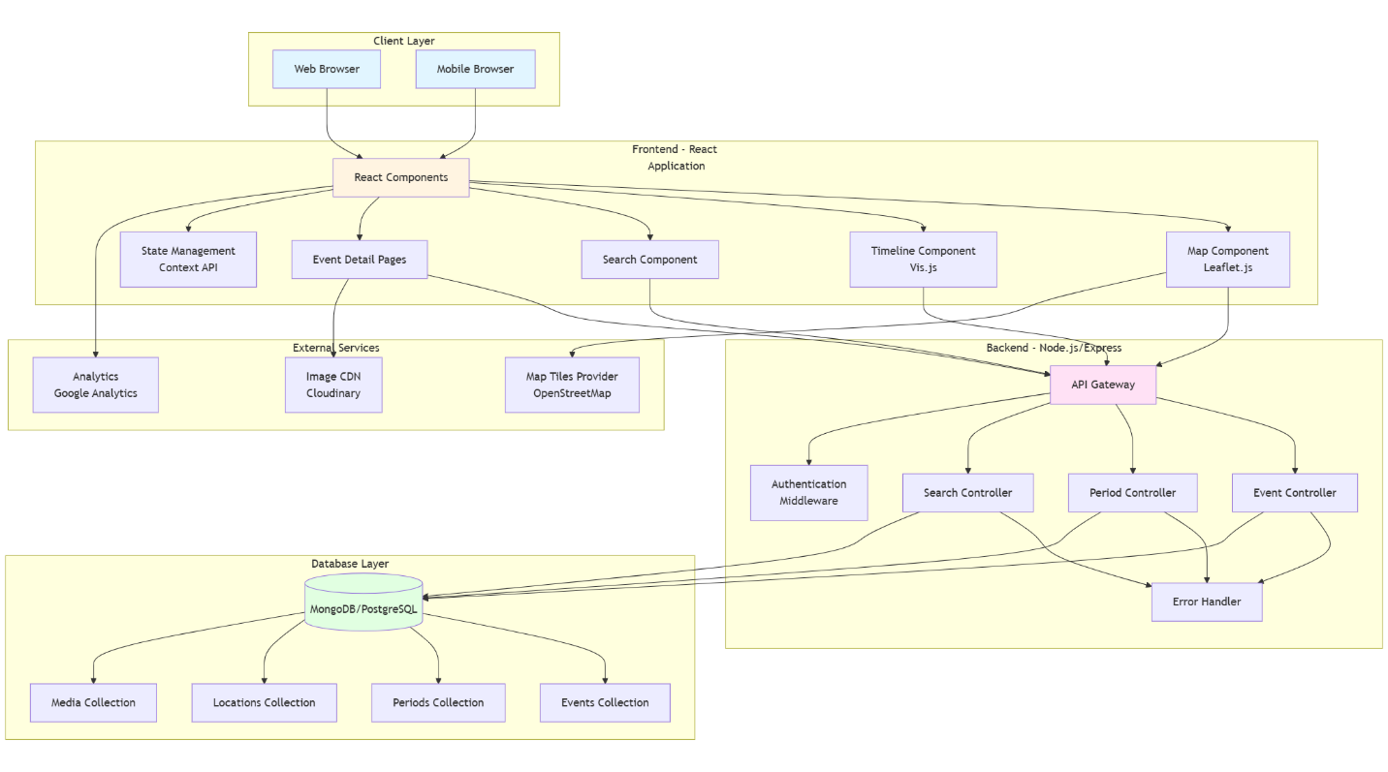

V. DATA AND RESOURCES

5.1. Data Sources
Primary Sources:
- Vietnamese historical textbooks (Ministry of Education approved)
- Academic papers and journals
- National archives and museums
- Wikipedia Vietnam history articles (for structure reference)
- Historical databases from Vietnamese universities
Geographic Data:
- Historical maps of Vietnam
- GeoJSON data for Vietnam boundaries
- Provincial and regional data
Multimedia Resources:
- Public domain historical images
- Creative Commons licensed photos
- Museum digital collections
- Educational video content (embedded)
Content Requirements:
- 50+ major historical events
- 10+ historical periods/dynasties
- 30+ historical figures
- Maps showing territorial changes
- Timeline data (dates, locations, descriptions)

5.2. Data Flow
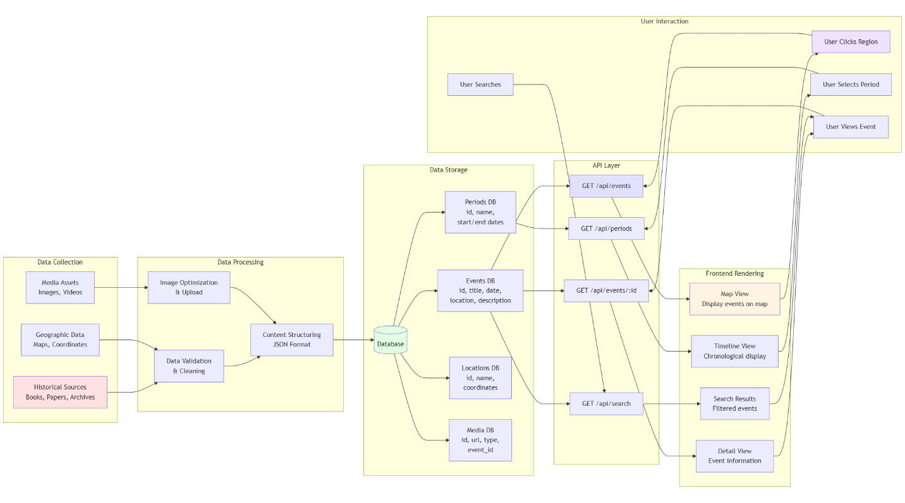

VI. PROJECT ROADMAP

6.1. Development Approach
- Methodology: Agile (2-week sprints)
- Team Size: 1 (Full-stack developer)
- Duration: 10 weeks (MVP)
- Work Schedule: 20-30 hours/week

6.2. Timeline

PHASE I: ANALYSIS AND DESIGN (Weeks 1-2)

Week 1: Research & Planning
Focus: Content research and system design
Tasks:
- Research Vietnamese history content (10 hours)
  - Collect data on major dynasties (Lý, Trần, Lê, Nguyễn, French Colonial, Vietnam War)
  - List 50+ significant historical events with dates and locations
  - Gather reliable sources and references
  - Collect or identify public domain images
- Define database schema (5 hours)
  - Design Events collection/table structure
  - Design Periods collection/table structure
  - Design Locations collection/table structure
  - Design Media collection/table structure
  - Create Entity-Relationship diagram
- Create wireframes (5 hours)
  - Sketch homepage layout
  - Design map interface
  - Design timeline view
  - Design event detail page
  - Design search results page
Deliverables:
- Historical content outline (50+ events documented)
- Database schema document
- Wireframe designs (5 pages)

Week 2: UI/UX Design & Technical Setup
Focus: Design finalization and development environment
Tasks:
- Create high-fidelity designs (8 hours)
  - Design homepage in Figma
  - Design map interface with color scheme
  - Design timeline component
  - Design event cards and detail pages
  - Choose color palette and typography
- Set up development environment (6 hours)
  - Install Node.js, npm, Git
  - Create GitHub repository
  - Initialize React project (create-react-app or Vite)
  - Set up Express.js backend project
  - Configure ESLint and Prettier
- Choose and configure tools (6 hours)
  - Set up MongoDB Atlas account OR PostgreSQL
  - Create Cloudinary account for images
  - Test Leaflet.js for maps
  - Research and choose timeline library
  - Set up project folder structure
Deliverables:
- Complete UI/UX design (Figma file)
- Development environment ready
- GitHub repository created
- Technology stack confirmed

PHASE II: BACKEND DEVELOPMENT (Weeks 3-4)

Week 3: Database & API Foundation
Focus: Backend infrastructure and API endpoints
Tasks:
- Database setup (6 hours)
  - Create database in MongoDB Atlas/PostgreSQL
  - Define collections/tables schema
  - Set up database connection in Express
  - Create seed data script
  - Test database connection
- Build core API endpoints (10 hours)
  - GET /api/events - Fetch all events
  - GET /api/events/:id - Fetch single event
  - GET /api/periods - Fetch all periods
  - GET /api/periods/:id - Fetch single period with events
  - GET /api/locations - Fetch locations with coordinates
  - Create error handling middleware
  - Set up CORS configuration
- API testing (4 hours)
  - Test all endpoints with Postman
  - Write API documentation
  - Test error scenarios
  - Verify data validation
Deliverables:
- Working database with schema
- 5+ API endpoints functional
- API documentation
- Postman collection

Week 4: Advanced Features & Data Population
Focus: Search functionality and content entry
Tasks:
- Implement search functionality (6 hours)
  - GET /api/search?q=keyword endpoint
  - Add text search indexing in database
  - Implement filtering by period, location
  - Test search relevance
- Content entry system (8 hours)
  - Enter 20-30 historical events into database
  - Upload and link images to events
  - Enter 5-7 historical periods
  - Add geographic coordinates for locations
  - Verify data accuracy
- API optimization (6 hours)
  - Add pagination for events list
  - Implement caching strategy
  - Optimize database queries
  - Add request rate limiting (optional)
Deliverables:
- Search API functional
- 20-30 events in database with images
- 5-7 periods documented
- Optimized API endpoints

PHASE III: FRONTEND DEVELOPMENT (Weeks 5-6)

Week 5: Core UI Components
Focus: React components and routing
Tasks:
- Set up routing (3 hours)
  - Install React Router
  - Create routes (Home, Map, Timeline, Event Detail, Search)
  - Implement navigation bar
  - Test navigation
- Build homepage (5 hours)
  - Create hero section
  - Display featured events
  - Add period filter buttons
  - Link to map and timeline views
- Interactive map component (10 hours)
  - Integrate Leaflet.js
  - Load Vietnam map tiles
  - Plot event markers on map
  - Implement marker clustering
  - Add click events to show event preview
  - Style map markers by period
- Connect map to API (2 hours)
  - Fetch events from API
  - Display events on map
  - Handle loading states
  - Handle errors
Deliverables:
- Functional navigation system
- Homepage with dynamic content
- Interactive map displaying events
- API integration working

Week 6: Timeline & Detail Pages
Focus: Timeline visualization and content display
Tasks:
- Timeline component (8 hours)
  - Integrate timeline library (Vis.js or custom)
  - Fetch events from API
  - Display events chronologically
  - Add period separators
  - Implement zoom and pan
  - Add click to view details
- Event detail page (6 hours)
  - Create event detail component
  - Display full event information
  - Show related events
  - Add image gallery
  - Link back to map location
  - Show on timeline position
- Search functionality (6 hours)
  - Create search bar component
  - Implement autocomplete (optional)
  - Display search results
  - Add filters (period, location)
  - Handle no results state
Deliverables:
- Working timeline view
- Complete event detail pages
- Functional search interface
- All major pages complete

PHASE IV: TESTING AND OPTIMIZATION (Weeks 7-8)

Week 7: Integration & Content Completion
Focus: Full system integration and content population
Tasks:
- Complete content entry (10 hours)
  - Add remaining events (reach 50+ total)
  - Add more detailed descriptions
  - Upload all historical images
  - Verify all dates and locations
  - Proofread all content
- Frontend-backend integration (6 hours)
  - Test all API calls from frontend
  - Handle loading states consistently
  - Implement error boundaries
  - Add retry logic for failed requests
  - Test with slow network
- Responsive design (4 hours)
  - Test on mobile devices
  - Adjust map controls for touch
  - Fix timeline on small screens
  - Ensure images are optimized
  - Test on tablet sizes
Deliverables:
- 50+ events fully documented
- All API integrations working
- Mobile-responsive design
- Complete content database

Week 8: Testing & Bug Fixes
Focus: Quality assurance and performance
Tasks:
- Functional testing (8 hours)
  - Test all user flows
  - Test map interactions
  - Test timeline navigation
  - Test search functionality
  - Test on different browsers (Chrome, Firefox, Safari)
  - Create bug list
- Performance optimization (6 hours)
  - Optimize image sizes
  - Implement lazy loading
  - Minimize bundle size
  - Add loading indicators
  - Test page load speeds
  - Optimize API response times
- Bug fixing (6 hours)
  - Fix high-priority bugs
  - Resolve UI inconsistencies
  - Fix broken links
  - Correct data errors
  - Test fixes
Deliverables:
- Comprehensive bug report
- All critical bugs fixed
- Performance benchmarks met
- Cross-browser compatibility verified

PHASE V: FINALIZATION AND LAUNCH (Weeks 9-10)

Week 9: Final Polish & Documentation
Focus: Final improvements and documentation
Tasks:
- UI/UX improvements (6 hours)
  - Add micro-interactions
  - Improve color contrast
  - Add loading animations
  - Polish transitions
  - Add tooltips and help text
- Create documentation (8 hours)
  - Write README.md
  - Document API endpoints
  - Create user guide
  - Write setup instructions
  - Document database schema
  - Add code comments
- Accessibility improvements (6 hours)
  - Add alt text to images
  - Ensure keyboard navigation
  - Test with screen reader
  - Check color contrast ratios
  - Add ARIA labels
Deliverables:
- Polished user interface
- Complete documentation
- Accessibility compliant
- Ready for deployment

Week 10: Deployment & Launch
Focus: Production deployment and monitoring
Tasks:
- Deployment setup (6 hours)
  - Choose hosting (Vercel, Netlify, Railway)
  - Configure environment variables
  - Set up production database
  - Configure CDN for images
  - Set up custom domain (optional)
- Deploy application (4 hours)
  - Deploy backend to Railway/Render
  - Deploy frontend to Vercel/Netlify
  - Test production environment
  - Verify all features work
  - Check API endpoints
- Launch preparation (6 hours)
  - Set up Google Analytics
  - Create social media posts
  - Share with classmates/teachers
  - Gather initial feedback
  - Monitor for issues
- Post-launch monitoring (4 hours)
  - Monitor server logs
  - Check error reports
  - Monitor performance
  - Collect user feedback
  - Plan future improvements
Deliverables:
- Live website URL
- Production environment stable
- Analytics tracking active
- User feedback collected
- Project complete!

